**A Morgan Stanley Whistleblower**

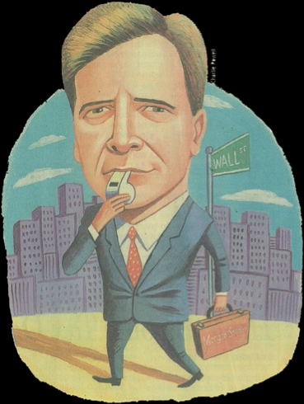

**Introduction**

There are reasons for engaging in this dispute and staying with it, without a script, and allowing facts and truth to evolve:

The specific reason for my willingness, after The Committee repeatedly asked me to finally come forward and tell this story, is to inform my former colleagues and their clients of the plot(s) they were in but didn’t know. The story is the story. Everything I am showing and telling you is the story.

Let me now extend to you all the opportunity for me to clarify and expand on points contained that may need further explanation. I have created a domain site containing documentation which will elaborate on The Story. The book itself will offer you the story, but for readers looking for supporting documentation, I have added those documents which will allow for a broader understanding of people involved.

Also, it was necessary to add some videos and audio emphasis which offers additional insights into The Story and me. It’s been 20 years of effort and it’s now time to let the truth be your guide. There will be prompts and codes to allow you to connect. It’s your choice how much depth you’ll choose to absorb but all I have included is relative.

The Committee is a collection of people I have interacted with over the years, including colleagues, to share with them what was being found by me. Trips to NYC, DC, Tallahassee, and Miami were keys to uncovering other people's interests which didn’t include yours.

So, even with some reticence in choosing to bring this forward, I want to say that I thought I could provide a complete remedy with those who are sworn to help protect investors, but I could not. I do hope that this will create the interest necessary to “encourage” Morgan Stanley to fully comply with the orders they have signed and repair the damage to the financial advisors and their clients.

You will read in other places, as well, what I am going to tell you now. This scheme, conspiracy, plot or whatever you choose to call it, was driven by the fixed income department of the firm initially, then legal, then upper management supported the process of keeping the violations from you. No financial advisor intentionally or deliberately misrepresented the surplus notes as bonds as they didn’t know they were ever surplus notes. In fact, I don’t believe that any financial advisors could give you a definition of a surplus note because we would never sell such a security to any of our retail clients. Nor were they ever made aware that there were 8 years of bluesky violations which, of course, included every sale of the Kemper Lumbermens Surplus Notes.

Now, if you are interested, follow the story along as I have written and documented it. I have done the best I can with an orderly presentation of the facts. The story was never expected to get this far, and you will no doubt see periodic grammatical and spelling errors contained in the blog notes and probably elsewhere. There will be some repetition from documents included from different time stages, but all that being said, I believe it’s all there for your understanding. After all, it’s just me telling the story and you need to know this story.

**Preface**

There are two types of categories of cowards that exist. The first type are those people who know about a scheme being concocted by people for self-serving reasons to disadvantage others and derive their own benefits from the actions. The second type would be those people who come to know this knowledge after the fact and decide to avoid the difficulty of facing off against the perpetrators. They run and attempt to hide and take no measures to address the wrongs they are now in possession of. You might suggest that they are virtually co-conspirators after the fact.

I am ashamed of my former firm Morgan Stanley for representing to me, my former colleagues and their clients a security known as the Kemper Lumbermen's Surplus Notes as a bond instrument, highly rated for investment grade fixed income clients, when, in fact, it was not a bond, but a surplus note, a totally alternate security. There, to the best of my investigation, was no purposeful wrongdoing by any of my financial advisor colleagues, but the culpability falls on upper management, the fixed income department and the legal department.

They misrepresented intentionally and deliberately the information you were given, and again, you did nothing wrong, and, as every broker knows, the remedy for this violation is rescission.

As a former compliance co-manager of 7 EF Hutton offices in Florida and an NASD/FINRA industry arbitrator, I was the financial advisor at Morgan Stanley who would do my best to evaluate and investigate what happened in the Surplus Note solicitation that was traded down to pennies by our firm while as late as November 2002. The fixed income department was encouraging the advisors who earlier purchased not to sell the security priced at that time at 50 cents on the dollar, totally in a junk category. It would be the rational conclusion that Morgan Stanley was the only firm involved with the surplus notes, so consequently no other firm was going to bail them out.

With Morgan Stanley stonewalling my efforts, I used my relationship with the NASD to cause an examination to be conducted through the NASD New Orleans office. But unbelievably their conclusions were to call it a bond pricing problem not the sale of a misrepresented security which led to my finding another amazing, cloaked violation. Morgan Stanley had violated the United States Blue Sky registration laws for eight years between 1997-2005 and though employees in the compliance department were aware, Morgan Stanley nor any of those employees took any action to remedy the situation. Every transaction sold without proper state registration by law is to be canceled out when identified.

I informed every division of securities of every state of the matter. Little did I know that they collectively had signed an order with Morgan Stanley in late 2008 for $8,500,000 outlining the infractions described above with rescission being the stated penalty for the violations. This order was never noticed to the financial advisors. There were no office meetings to inform, nor did it make it to the Division of Securities of the State of Florida press room.

Consequently, the financial advisors and their clients remained in the dark.

I feel it now necessary to inform my former colleagues as to the intentional and deliberate behavior of both Morgan Stanley and the regulators. We rightfully have always had an expectation as to the protection of ourselves and our clients under the regulatory umbrella.

I don't have a clear understanding of the regulator's motives, nor why the WSJ would not follow up on the original article they wrote about me on May 24, 2008 which elicited my need to stay in and fight on for well over the past decade.

I am sorry to the brokers for their loss of clients and their reputations for the surplus notes' debacle. I know the firm solicited us actively to sell this to our very best clients which would include family members.

This has been a 19-year pursuit in attempting to recover monies through rescission for the investors across the United States along with what appears to be approximately 30,000 additional transactions of unregistered securities for which there is no indication of oversight from the states nor the SEC.

There is much more depth to the story than this brief synopsis, but now you know that you collectively did not sell a bond but were duped into selling a surplus note virtually worthless when we were originally preyed upon. I wanted you to know that I tried the best I could for 19 years. Now let me tell you how this ensued and why there is a remaining opportunity to try to reverse this travesty.

**Monograph**

# TIMELINE OF EVENTS

January 2001 Morgan Stanley began representing the Kemper Lumbermen Surplus Notes (KLSN) as bonds to brokers and clients. Morgan Stanley manufactured and created the retail market for the KLSN sale and was likely the only firm participating in the pricing through the collapse of the notes in 2003.

January 2003 Morgan Stanley Stuart, FL employee Mike Blankenship was dismissed after notifying the firm’s legal department that the KLSN were not a suitable investment for his clients. Morgan Stanley broker Dana de Windt inherited some of Blankenship’s clientele and a suit was filed on behalf of six customers, including de Windt’s father.

Nov 2004 Mr. de Windt initiated a call to the Division of Enforcement of the United States Securities and Exchange Division special counsel Donna Norman. To his knowledge, the SEC never engaged in a review of the matter at that time.

February 2005 During mediation with Morgan Stanley, five of the six plaintiffs settled for 50% of the cost of the surplus notes. Mr. de Windt does not settle, meets with the FL compliance division of the NASD and through their New Orleans office, a further examination of the KLSN issues was agreed upon.

August 2007 The newly formed FINRA releases its findings of the KLSN sales by Morgan Stanley and orders a $6.1 million fine for pricing violations.

January 2008 Mr. de Windt informs the Florida Division of Securities office in Tallahassee that investors are entitled to rescission payments for the violations noted in the FINRA order.

April 2008 Frustrated with Morgan Stanley’s practices and stonewalling, de Windt leaves the firm. Four weeks later the WSJ whistleblower story appears.

May 2008 Two days after the WSJ article runs, de Windt receives a call from a former Ohio-based Morgan Stanley broker that his clients had received *unsolicited* rescission stemming from sale of KLSN in January of 2007.

July 2008 Mr. de Windt receives confirmation that Florida’s Division of Securities office will look into rescission payments for Morgan Stanley customers who unknowingly purchased KLSN believing they were bonds.

Sept 2008 Florida’s Division of Securities office notified de Windt that 738 Morgan Stanley investors were eligible to receive rescission payments for pricing violations under Florida statute 517.061 (17). The statute stems from pricing violations only, not the soon-to-be discovered Blue Sky Law violations which also occurred.

Nov 2008 Mr. de Windt learns the rescission offers were not going to be sent certified mail nor were Florida regulators going to send out a notice to investors. Mr. de Windt objects formally with the general counsel Rex Staples of the North American Securities Administrators Association (NASAA).

October 2008 Morgan Stanley mails Florida investors rescission notices with a 30 day notice for restitution. No follow up is made to clients. Of 738 investors in Florida, only a purported 414 received, understood and took the rescission offer which totaled $8.4 million.

January 2009 Mr. de Windt objects and travels to the District of Columbia to meet with the NASAA general counsel and discovers that the NASAA and Morgan Stanley reached a settlement for $8.5 million with additional states (including FL) never previously mentioned. The settlement was never made public by the NASAA, Morgan Stanley, nor by the states where the violations occurred, thus not allowing any notice to investors who were defrauded by the sale of KLSN and other securities. The document uncovers the fact that Morgan Stanley’s compliance department was aware of compliance infractions for eight years, from 1997-2005, and chose not to address the issues. Furthermore, all government regulatory agencies were aware of the firm’s Blue Sky infractions since mid 2005.

Feb-May 2009 Mr. de Windt met with SEC branch chief Michael S. Fuchs and senior counsel Natasha Vij Greiner to request involvement of the Commission to negotiate a resolution with the NASAA. A written response claimed it was outside the SEC staff’s authority.

Jan 2010-2014 Mr. de Windt continues work to ensure Morgan Stanley investors receive their due rescission payments. In his quest to right the wrongdoing, he has met with multiple government agencies including the FBI, SEC, NASAA, FFETF and FINRA to make Morgan Stanley investors whole and to ensure stricter compliance measures.

October 2013 de Windt requested that enforcement from the US Attorney’s Office in the SDNY discharge their responsibility to make the events legally right. No communications and no interest.

**Key Definitions**

# Bonds

In [finance,](http://en.wikipedia.org/wiki/Finance) a bond is an instrument of indebtedness of the bond issuer to the holders. It is a debt [security,](http://en.wikipedia.org/wiki/Security_(finance)) under which the issuer owes the holders a debt and, depending on the terms of the bond, is obliged to pay them [interest](http://en.wikipedia.org/wiki/Interest) (the [coupon](http://en.wikipedia.org/wiki/Coupon_(bond))) and/or to repay the principal at a later date, termed the [maturity](http://en.wikipedia.org/wiki/Maturity_(finance)) date. Interest is usually payable at fixed intervals (semiannual, annual, sometimes monthly). Very often the bond is negotiable, i.e. the ownership of the instrument can be transferred in the secondary market. This means that once the transfer agents at the bank medallion stamp the bond, it is highly liquid on the second market.

Bonds and [stocks](http://en.wikipedia.org/wiki/Stock) are both [securities](http://en.wikipedia.org/wiki/Security_(finance)), but the major difference between the two is that (capital) stockholders have an [equity](http://en.wikipedia.org/wiki/Equity_(finance)) stake in the company (i.e. they are investors), whereas bondholders have a creditor stake in the company (i.e. they are lenders). *Being a creditor, bondholders have absolute priority and will be repaid before stockholders (who are owners) in the event of bankruptcy.*

# Surplus Notes

In the United States a contingent surplus note is a [bond](http://en.wikipedia.org/wiki/Bond_(finance))-like instrument issued by an [insurance](http://en.wikipedia.org/wiki/Insurance_company) [company.](http://en.wikipedia.org/wiki/Insurance_company) These [securities](http://en.wikipedia.org/wiki/Securities) are subordinated obligations, and fall at the very bottom of the operating insurance company's [capital](http://en.wikipedia.org/wiki/Financial_capital) structure. They are issued primarily by [mutual insurance](http://en.wikipedia.org/wiki/Mutual_insurance) companies, which are not public and owned instead by their policyholders. Surplus notes are [debt](http://en.wikipedia.org/wiki/Debt)-like in that they pay a coupon and have a finite maturity. However, in many cases, state insurance regulators have allowed insurance companies to classify the *capital raised via surplus notes as “surplus” (which is the statutory equivalent of* [*equity*](http://en.wikipedia.org/wiki/Shareholders%27_equity)*), because surplus note holders are last in line to make a claim on the company's assets in a* [*defaul*](http://en.wikipedia.org/wiki/Default_(finance))*t scenario*, much like where equity holders reside in a public company. The motivation for mutual companies to issue these instruments was to raise surplus (or equity) in response to new risk-based capital guidelines developed in the early 1990s.

# NASAA

Organized in 1919, the North American Securities Administrators Association (NASAA) is the oldest international organization devoted to investor protection. NASAA is a voluntary association whose membership consists of 67 state, provincial, and territorial securities administrators in the 50 states, the District of Columbia, Puerto Rico, the U.S. Virgin Islands, Canada, and Mexico. NASAA works with regulatory counterparts to collectively protect investors. NASAA members also provide insight from their unique perspective to the SEC and SROs as they move forward in their rulemaking process.

# FINRA/NASD

Financial Industry Regulatory Authority dedicated to investor protection and market integrity through effective and efficient regulation of the securities industry. FINRA is not part of the government but is an independent, not-for-profit organization authorized by Congress to protect America’s investors by making sure the securities industry operates fairly and honestly. Independent regulation plays a critical role in America’s financial system—by enforcing high ethical standards, bringing the necessary resources and expertise to regulation and enhancing investor safeguards and market integrity—all at no cost to taxpayers.

The National Association of Securities Dealers was a self-regulatory organization of the securities industry responsible for the operation and regulation of the Nasdaq stock market and over-the-counter markets.

# Rescission

Rescission has been defined as the unmaking of a contract between parties. Rescission is the unwinding of a transaction. This is done to bring the parties, as far as possible, back to the position in which they were before they entered into a contract

# Blue Sky Laws

A Blue Sky law is a [state](http://en.wikipedia.org/wiki/U.S._state) law in the [United States](http://en.wikipedia.org/wiki/United_States) that regulates the offering and sale of [securities](http://en.wikipedia.org/wiki/Security_(finance)) to protect the public from [fraud.](http://en.wikipedia.org/wiki/Fraud) Though the specific provisions of these laws vary among states, they all require the registration of all securities offerings and sales, as well as of [stockbrokers](http://en.wikipedia.org/wiki/Stockbroker) and [brokerage firms.](http://en.wikipedia.org/wiki/Brokerage_firm) Each state's Blue Sky law is administered by its appropriate regulatory agency and most also provide private [causes of action](http://en.wikipedia.org/wiki/Cause_of_action) for private investors who have been injured by [securities fraud.](http://en.wikipedia.org/wiki/Securities_fraud)

The first Blue Sky law was enacted in [Kansas](http://en.wikipedia.org/wiki/Kansas) in 1911 at the urging of its banking commissioner, [Joseph Norman Dolley,](http://en.wikipedia.org/wiki/Joseph_Norman_Dolley) and served as a model for similar statutes in other states. Between 1911 and 1933, 47 states adopted blue-sky statutes (Nevada was the lone holdout). Today, the Blue Sky laws of 40 of the 50 states are patterned after the [Uniform Securities Act](http://en.wikipedia.org/wiki/Uniform_Securities_Act) of 1956.

Blue Sky laws have antifraud provisions that create liability for any fraudulent statements or failure to disclose information as required. The specific kinds of statements and acts that can form the basis of a fraud claim will depend on a state’s statutes and case law. The right of action available and remedies available to investors bringing private suits also differs from state to state, but may include [rescission](http://www.lectlaw.com/def2/q152.htm) of the transactions, forcing the seller to give up profits, or other measures of damages.

Given the size of many companies and brokerage firms and the fact that most wish to sell securities in multiple states, the Blue Sky laws make transactions more difficult because companies must comply with the law of each state where they sell or offer securities.

# Blue Sky Laws (con’t)

In reaction, Congress has passed legislation over time that preempts Blue Sky laws where laws duplicate federal law. States now have limited power to register and review securities.

The [1996 National Securities Markets Improvement Act of 1996 (NSMIA),](http://frwebgate.access.gpo.gov/cgi-bin/getdoc.cgi?dbname=104_cong_public_laws&docid=f%3Apubl290.104.pdf) amended [Section15(h)](http://uscode.law.cornell.edu/uscode/html/uscode15/usc_sec_15_00000078---o000-.html) of the Securities Exchange Act of 1934. Now, federal law controls in certain aspects of the regulation of broker-dealers, such as record-keeping, financial standards, and operating requirements. In addition, the NSMIA amended the Securities Act of 1933 so that certain types of securities are no longer subject to state registration laws. However, offers and sales must

still be registered, market participants must still register per a state’s blue skies laws, and state fraud laws are still available as causes of action for individual investors.

# Kemper Lumbermens

Kemper Corporation was founded by James S. Kemper in 1912 to cover the Midwest’s sawmills and their workers. A powerhouse in the insurance industry, the IL-based company faced financial hurdles in the early 2000s and downgrades related to the company’s performance began. In January 2003, financial global rating agency, Fitch, announced that it had lowered

Kemper’s ratings on the three underwriters to ‘B+’ from ‘BBB’ and its Lumbermens Mutual and Casualty Company from ‘BB’ to ‘CCC.’ Industry experts observed that at those levels the group’s securities “are mostly below investment grade, and this affects their interest rate and the discount price.”

# HOW THE FRAUD OCCURRED

**Three Indisputable Facts about Morgan Stanley**

1. Morgan Stanley violated Blue Sky Laws in all states from 1997-2005
2. Morgan Stanley made investor settlements in TN without a request from customers for the rescission
3. Only after years of prodding did Morgan Stanley agree to pay rescission for its fraudulent practices in Florida, but when it did so, it buried the truth from customers and made it difficult for investors and their brokers to understand what occurred

# Background

A security, Kemper Lumbermen’s Surplus Notes, was represented to Morgan Stanley brokerage financial advisors in early 2001 as an investment grade bond when, in fact, according to a prospectus never shared with brokers or their clients, the surplus notes were actually “unsecured and subordinated to all present and future indebtedness” and were “not part of the legal liabilities of Lumbermens.” Morgan Stanley brokers were purposefully led into selling and misrepresenting a security, and the proper remedy according law is rescission. A surplus note security may not be passed off as an investment grade bond. The surplus note is an entirely different security, with lesser safeguards—and when the sales occurred, the financial health of the holder, Kemper Lumbermens, was already spiraling downward.

According to former Morgan Stanley broker Dana de Windt, within the Morgan Stanley compliance manual there is a straightforward demand from its founding father:

*“Every employee of the firm is responsible for preserving and protecting Morgan Stanley’s reputation for integrity and excellence. You are expected to do more than simply follow the applicable rules - you are required to escalate promptly potential legal, regulatory and ethical misconduct.”*

Dana de Windt followed the requirements of the firm, and it led to a discovery of multiple violations including the firm’s decision never to tell its brokers about the KLSN material event. The brokers were expressly mislead and did not know that the security was a surplus note. In fact, both the brokerage statements and the confirmations of the trades did not include the proper description of the security. The culprits were top Morgan Stanley management, the company’s bond and legal departments, and surprisingly, the firm’s regulators.

For more than a decade, Dana de Windt has been trying to bring these fraudulent actions to light and to gain restitution in the form of a rescission payment to duped clientele. “It has been a long and difficult fight to protect thousands of investors’ rights of recovery,” says de Windt, “now it is time to correct this very egregious and unlawful behavior allowed by Morgan Stanley.”

# Tip of the Iceberg

Blue Sky violations can be traced back to the February 1997 merger between Morgan Stanley and Dean Witter**.** In May of 2005, Morgan Stanley released findings that demonstrated at least an eight year violation of the Blue Sky laws, of which KLSN fell into that category. The findings cite, “Although some of Morgan Stanley’s employees in its compliance department were aware that Morgan Stanley Dean Witter did not have an adequate fixed income Blue Sky registration verification system, neither Morgan Stanley, nor any of its employees took any action to rectify the situation**.”**

# Uncovering the Truth

An early move made by de Windt in March 2005 translated into the FINRA order to fine Morgan Stanley $6.1 million for violations. FINRA, which was the NASD at the time of the examination, knew that Morgan Stanley violated the Blue Sky laws as is indicated in the settlement orders signed later in 2008. *(The 24 page final order from Florida’s Office of Financial Regulation can be furnished upon request.)* Violating state Blue Sky registration laws should have allowed FINRA to compel immediate rescission from Morgan Stanley to its customers that time. This did not occur.

*Interestingly, FINRA never mentioned the Blue Sky registration violations in the August 2, 2007 order or publicly anywhere. Mr. de Windt asks, why?*

Mr. de Windt discovered the Blue Sky law violation documents in early 2009 after meeting on his own accord with the general counsel of the NASAA in Washington, DC. The information did not come from the regulatory counsel during the face-to-face meeting, only afterwards, when curiosity piqued de Windt and he located the document on the internet. The research uncovered a settlement for $8.5 million of which 100% accrued to the benefit of the states under the banner of the NASAA. *Incredibly, investors did not receive any restitution from this settlement and were, in fact, unaware of its existence*. Implausibly, when de Windt challenged NASAA counsel Rex Staples about this discovery he was met with a defensive retort, ”You’re charging me with malfeasance?”

Morgan Stanley did provide partial rescission, but their documents clearly stated that there was only a “14% take up rate” on the “main offering.” There is no clear evidence that Morgan Stanley had any oversight in complying with this rescission action: not from the states where the sales took place, nor from FINRA, or as it turns out, the SEC. The rescission payouts in Florida pushed through by the concerted efforts of de Windt were used by Morgan Stanley to suggest that the firm was in compliance, but evidence shows the opposite.

# Leaving Morgan Stanley & Subsequent Media Attention

After years of pursuing Morgan Stanley and regulators to find a fair resolution to the serious infractions Morgan Stanley imposed on its own brokers and clients, de Windt became frustrated with the firm’s lack of adherence to law and integrity to its customers and decided to leave the firm in April of 2008.

His cause gained some traction in the media with a *Wall Street Journal* profile in May 2008 and then again in June from the blogger Blue Jean Millionaire <http://www.bluejeansmillionaire.com/2008/06/10/morgan-stanley-whistleblower/>

As a direct result of the media coverage, de Windt received a call from a former Morgan Stanley broker in Ohio who informed him that clients in Tennessee were offered complete rescission in January 2007 for the purchase of KLSN. Those payments included a 10% interest penalty (per Blue Sky Law) and dated back to the purchase date of 2001.

From this call, de Windt learned:

* Morgan Stanley made full rescission payments in Tennessee without provocation from clients
* These rescission payments were made nine months before FINRA’s consent order to

make similar payments in Florida and elsewhere

* Morgan Stanley completed the Tennessee rescission payments without letting the security division of Tennessee know of the matter

Since he left Morgan Stanley, de Windt, on his own initiative, has personally met with the FBI several times, the SEC, FINRA and the NASAA to try and make his former employer accountable.

# Mr. de Windt’s Motivation and Background—In His Own Words

As a former compliance manager for EF Hutton overseeing seven offices and an industry arbitrator under NASD/FINRA for over a decade, I felt compelled by nature to resolve the issues that were so flagrantly in error. My background in compliance allowed me to pursue the corrections while remaining a broker for the firm for five years.

The $8.4 million settlement I pushed for, however, did not in my opinion rectify the situation. Florida Division of Securities, at the time claimed that the payout was an “informal settlement” as a result of a pricing issue with the notes. However, Florida’s Division of Securities reported in a June 30, 2009 financial report that “Morgan Stanley paid a voluntary $8.4 million in restitution to in-state investors for the sale of the unregistered securities of Kemper Lumbermens Surplus Notes.”

When I thought about the outrageous treatment of colleagues and clients, I could not let the subject drop, even though I had no financial stake in the matter. Further research proved to me that Morgan Stanley may have violated Blue Sky laws by misrepresenting securities sold in 30,000+ transactions. When further looking into Blue Sky violation payments, I found that an additional interest rate penalty associated with the infraction should also be included in the payment. I have a redacted 5,000+ investor transaction list from Florida, and I do not believe that the State of Florida, after personally challenging them for over a year, provided one ounce of oversight even though they received more than $1.2 million for their share in signing the settlement between the NASAA and Morgan Stanley, which occurred on September 24, 2008.

Morgan Stanley erroneously presumes that I am no longer involved after being an expert witness in December of 2012 in arbitration and earning the plaintiff a $40,000 recovery on these

same surplus notes. I initiated the arbitration with the assistance of attorney Rose Schindler and prevailed. It offered me an inside look at whatever defense they chose to use, and it was hollow at best.

I have too much respect for those brokers who had their reputations battered due to the fraudulent practices of Morgan Stanley *(and the inactions of the regulatory agencies*) to go quietly away. From that arbitration, I understood clearly that Morgan Stanley continues to have no defenses, especially along the lines of statute of limitations. Fraudulent concealment of material information related to this material event is clearly evident. My goal simply is to reach a final and proper solution for Morgan Stanley clients.

I honestly thought, as I once had a high regard for our industry, that regulation was a fair playing field and would solve this with all evidence provided, but I was mistaken. Without resolution from regulators (FINRA, NASAA and SEC), I have since contacted law enforcement including the FBI, the FFETF and the Southern District of New York’s United States Attorney’s Office. I submitted to the Crime Reports Unit a full summary of the matter and, at this time, they have not responded.

I have often asked myself if I am misguided or being irrational to pursue this for more than 19 years. Of course, if at any time Morgan Stanley or the regulatory agencies held themselves accountable, I believe my pursuit would not have been this relentless. Quite frankly, I have been dumbfounded by the roadblocks thrown up to prevent the right thing being done. Knowing that investors are so completely uninformed about the fraudulent transgressions taking place in this matter is also a driving force.

If you would like to learn more and see detailed documentation for this chapter, please visit our website at www.mswhistleblower.com. There, you will find extended information to help you get the best understanding through video, audio and supporting files.

**Responsibility to Engage**

When you enter into a situation like this, with literally no information, one would have no reason to think that it was going to be any more difficult than just making a few inquiries and getting some answers. But in this case, that was different. I do want to tell you that the policy on reporting potential illegal and unethical conduct at Morgan Stanley states the following: “every employee of the firm is responsible for preserving and protecting Morgan Stanley's reputation for integrity and excellence. You're expected to do more than simply follow the applicable rules. You are required to promptly escalate potential legal, regulatory, and ethical misconduct”. And that's what I did. I did send a general letter to five people at Morgan Stanley asking for their response to the problem. And I also informed the SEC in October of 2004, that there was a situation where I couldn't get my arms around yet, but I needed their help. And as far as I can tell, their response was to do nothing until I, with assistance from Donna Norman, arranged for an on site meeting with the SEC for about 2 hours in 2009 to allow them to engage. They eventually, in an email, responded that this was a state’s issue. Of course, when the states fail to discharge, it becomes theirs, pure and simple.

If you would like to learn more and see detailed documentation for this chapter, please visit our website at www.mswhistleblower.com. There, you will find extended information to help you get the best understanding through video, audio and supporting files.

**The NASD/FINRA mediation and examination**

Richard Mittnacht was a client I inherited from Mike Blankenship on January 3, 2003. Rich was determined to get to the bottom of the Lumbermens' issues, and he was able to retain a Boca Raton firm as long as we had 6 clients willing to be part of the action. It did happen in February of 2005 in mediation initially, with me involved. Morgan Stanley was, of course, not forthcoming with real and honest disclosure and the legal firm chose to inform the 6 clients that they were no longer going to represent any of the 6 in the upcoming arbitrations, scheduled in the next several weeks. In other words, the attorney for us the plaintiffs provided an ultimatum of either settle or good luck replacing us in the next 2 weeks to continue with the arbitration. So, 1 by 1, each of them entered the Morgan Stanley conference room to hash out their settlement while, naturally, I was going to be last.

When the 5th client disappeared into their chamber, I left and went back to Stuart without notice. Remember, I was still employed by Morgan Stanley at the time. I had no interest in any settlement with the firm if I didn’t know exactly what the infractions were. They called me and I said I would choose to continue my financial advisor duties which I did, but I had contacted the NASD with direction and encouragement to conduct an examination. I was fortunate to have skilled people listening and acting on the clients interests at that moment.

The examination by the NASD commenced shortly after and was concluded in early May of 05. We were able to communicate with the lead examiner Gene Davis out of their New Orleans office, and we had appreciated his candor during a couple of conversations.

Mike Blankenship and I were able to speak with him shortly after he concluded his examination. His response was this: this examination was the easiest and straightforward examination he had taken part in, and it would result in the largest award in the history of the NASD. The time frame for his comment was sometime after May of 2005. At that point the waiting game began for over 2 and a quarter years with the culmination released on August 2, 2007.

It was clear after the FINRA news release of fining Morgan Stanley $6.1 million for overcharging in customer “ bond sales”, that they had not reflecting Gene Davis’s comment to us that this would be an unprecedented award. Also, the NASD one day before this release on August 1, 2007 changed its name to FINRA, the day before their order on Lumbermens was made public.

One can only deduce that Gene was referring to both the Blue-Sky law violations and the misrepresentation of the surplus notes as bonds. I believe I know who stepped in and quashed these findings, but I prefer to hold off on his and her identification. Gene Davis, until his superiors prevented us from contacting him, was cooperative and accepted our few calls willingly. Gene has the knowledge of how the award he was expecting was fully diminished in the FINRA consent order of August 2, 2007 and so does his former boss Mitchell Atkins who assisted in arranging the examination in 2005.

Therefore, you could never inform your clients. You didn't know which securities were involved. I mean, it's really an unparalleled breach of fiduciary that the firm had to everyone in the first place. This employee, Kenneth Carberry IV, was solely identified, fined and suspended at Morgan Stanley for a short time as mentioned in the FINRA order of 8/2/2007. I think we ought to hear from Mr. Carberry, as to what role he played in this whole duping of surplus notes pretending to be bonds and unregistered. Morgan Stanley fought like a tiger to keep me from being able to depose Carberry in the ongoing arbitration I had. And remember, the compliance employees at Morgan Stanley were aware of the Blue Sky violations long before they were uncovered by the NASD/FINRA examination out of their New Orleans office which I caused.

You’ll read shortly in the consent order with the states found by me in late 2008, Morgan Stanley admitted to “self informing” on their blue-sky problem in May of 2005, coincidentally at the time of the conclusion of Gene’s examination. If they “self informed,” they would have done it without the help of the examination I caused years before 2005. I have been blacklisted from any contact with the FINRA agency for years now as I asked multiple times, after learning of all the violations, that FINRA to go back and revisit their findings. Their lawyer I tangled with from DC was Terri Reicher, abrupt, arrogant and disinterested in the facts of the matter and the investor’s welfare. You’ll read an exchange with her shortly.

If you would like to learn more and see detailed documentation for this chapter, please visit our website at www.mswhistleblower.com. There, you will find extended information to help you get the best understanding through video, audio and supporting files.

**Contacting the WSJ For their support**

One of the most fascinating parts of the story was, as we then knew, the FINRA examination was concluded about May of 2005. And by the spring of 2006, we hadn't heard of a word from the agency. And the Regional Chief Counsel in New Orleans, Andrew A Favret, was not forthcoming in any fashion as to what they did find relative to the examination.

So, three of us were getting together in the spring of 2006, and concluded that we ought to ask the Wall Street Journal to make a phone call, inform FINRA that they knew the examination had concluded and ask them for an update. And so we did, we called and spoke to reporter Randall Smith, who seemed interested, and in fact, wanted to come down to Stuart, to meet with some of the brokers and some of the clients who had been disadvantaged.

He arrived and took as much information as he could, and literally never did a thing except sit on the story. So, another year went by, we're now in the summer of 2007. And finally, on August the second 2007, FINRA came out with their totally improper findings of the bond overpricing problem. Oh, I agree that it was also a pricing problem but, as I would find out later, it was both a sale of an unregistered security and misrepresented as a bond and not a surplus note. If you read the monograph above, I have offered the definition of both to you. They deliberately solicited the financial advisors to sell a surplus note that they called a mutual note on the confirm and statement. They misjudged the ramifications of this surplus notes going through the floorboards over the next year. I spoke to Merrill Lynch and UBS about their knowledge of these notes and they did not participate in them at all. I believe MS must have been the only firm making a market which put them in grave danger over the next year. That's when I got more interested in meeting with the states representative and so forth.

The WSJ sat on the story until 8 months after the FINRA release of August 2, 2007. Unbelievably, within a month after informing Randall Smith that I was no longer in the employment of Morgan Stanley, out comes the article in the Wall Street Journal on May 24, of 2008, with an interesting caricature of me, with a whistle in my mouth, “broker Dana de Windt blew the whistle” and calling me a Morgan Stanley Crusader. It was fine I suppose. The article was clever, I guess, but it was brought out 8 months after FINRA’s release in August of 2007. And here he's dropping this thing in May of 2008. So I read it and that was it.

Then I got a phone call the next day, one phone call in the entire United States from a fellow financial advisor in Ohio, Wayne Dodds. He said, I just want you to know that I appreciate what you did in trying to get to the bottom of this. But I want to tell you that I have clients in Tennessee, and in January of 2007, they received a rescission opportunity with Morgan Stanley on Kemper lumbermen’s surplus notes without ever asking or soliciting. Seriously!!! Well, my short reprieve from chasing Morgan Stanley was brief and so on we go.

There were no actions in Tennessee being taken. But, Morgan Stanley found it in their best interest to go into Tennessee in January of 2007. The FINRA findings didn't even come out until August 2, 2007. You've got a seven-month gap, of which Morgan Stanley presumably didn't know what FINRA was coming up with. And they wanted to give people back their money without them asking for it? I called the State of Tennessee and asked Daphne Smith, who was the commissioner, what do you know about this? I mean, if Morgan Stanley was taking it upon themselves to recognize a violation that they made in Tennessee, and they were going to correct the violation without you knowing it, I would say that would be one big breach of the relationship between the firm and your state. There must have been some pressure on Morgan Stanley to address this with Tennessee investors, but noone has been forthcoming with that information.

Quite honestly, I couldn't get a legitimate answer from the state of Tennessee. And, by the way, Tennessee received over $274,000 for signing the consent agreement with Morgan Stanley in 2008. Therefore, that should correlate to over 1000 breaches of blue-sky violations. Neither Daphne nor Carmen Jones, nor the follow-on Commissioner when we pressed them to give us some answers, was forthright in addressing specifics.

If you would like to learn more and see detailed documentation for this chapter, please visit our website at www.mswhistleblower.com. There, you will find extended information to help you get the best understanding through video, audio and supporting files.

**Ramifications of the Wall Street Journal**

When I went back to the Wall Street Journal to tell them that their article had elicited the call from Ohio, which set this thing on a whole different level of pursuit, I actually thought that when I walked out of Morgan Stanley, this was all I could do. But when I found out about the activities in Tennessee, it was difficult to unengage. So, I asked Randall Smith to continue to cover the story with a nice letter saying I believed it's their responsibility because they caused these actions to happen to stay on it. And they wouldn't budge.

Now, when you have a story as big as this one, and your initial reporting was significant enough to bring information back that continued to move the story forward, and you don't want to do it, something caused that to happen. Now, I can speculate on this a little bit.

My impression is that they probably received a phone call from the legal department of Morgan Stanley, a day or two after this article came out, suggesting why in the world are you writing a story about Dana de Windt on an action that's already been covered and processed by FINRA? Not only that, the action took place approximately six months before you came out with this article. Morgan Stanley would have been incensed about seeing me coming around another corner when they and FINRA had processed an incompetent and virtually worthless order not addressing either the blue-sky violations nor the misrepresented KLSN violations.

And you as readers can decide what ramifications might have been insinuated by continuing to put me in a position where I'm moving the story forward. So that being the case, I elected to talk to a person at the New York Times. She was Gretchen Morgenson, who, incidentally, had been a former Dean Witter broker, a firm which Morgan Stanley purchased in the 1990’s. And I told her that the WSJ wasn’t going on it, and that I would provide her with all the information. I wrote her officially, but the New York Times and Gretchen decided that they would not move along on this either.

If you would like to learn more and see detailed documentation for this chapter, please visit our website at www.mswhistleblower.com. There, you will find extended information to help you get the best understanding through video, audio and supporting files.

**The NASAA Meeting in DC**

Although I didn't have full information at the time when I went to Washington, I met with the general counsel of the North American Securities Administrators Association to talk with him about my knowledge that Florida was not addressing the rescissions correctly simply based on the excessive overcharging on the “bond pricing”. We seemed to have a constructive conversation for about 40 minutes, and he said he'd look into it. His name is Rex Staples. Interesting to note that he was unwilling to schedule a meeting with me in his office, so I attended an offsite meeting with FINRA where I was able to engage him. He seemed interested but never mentioned their $8,500,000 consent order with the states even though it was out without informing the MS financial advisors.

So, I went home back to Florida and decided to search “Morgan Stanley'', the “NASAA”, which incidentally is the group of directors of the divisions of securities for the states and territories and “rescission” and out popped the first of many consent orders between Morgan Stanley and the states outlining the violations of the blue-sky laws, which I've mentioned earlier. As I am finishing this, The State of Missouri and Washington are still on the search. Look for yourself. I was also able to eventually find a prospectus on the KLSN's from 1996-97 which clearly pointed out that the security was a surplus note and not a bond. You’ll be able to read the language for yourself in the document below.

I will say that as a follow on to the Rex Staples conversation and my finding the consent agreement, I gave him a call. This was only a couple of days after I'd gotten back. I said, Rex, I certainly appreciate the time you spent with me the other day but when I got home, I did find this consent order, which is templated in a way that would seem to be an originating document from the NASAA. And I wondered, because you had not mentioned it, who's going to compel Morgan Stanley to comply with the orders found in the document?

His response to me, and you can see why this is easy to recall was, “you're charging me with malfeasance!” His other noteworthy comment to me even before I sat down with him for the meeting was so incredible that I am choosing to withhold it at this time. Maybe at a later date. I will say this: when a person chooses to withhold candor from you, they will say almost anything. It was very obvious that he knew who I was and the subject matter, and when I found the consent order, it threw him off.

When you read the order which I have highlighted, can you imagine that the violations in the order were never shared with the financial advisors, so they had no way of having the knowledge necessary to defend their clients? First, you were selling a surplus note disguised as a bond, and, next, you were involved with 8 years of blue-sky law violations. Rescission is the remedy, outlined in the consent order, but other than my leaning on Florida, there is no indication of other states providing the oversight they needed to, especially since many of them were receiving a portion of the $8,500,000 settlement. If you are one of the financial advisors caught in this, it’s a tough pill to swallow.

So, when I could elicit a reaction like that from Rex Staples, who I just met the other day, after a cordial conversation, I know this thing had an awful lot of depth to it. And that sent me moving again.

So, I once again took it upon myself to address everyone’s interest by attempting to meet with the SEC. Donna Norman agreed to assist and that email went out January 28, 2009. They finally agreed to meet with me in Washington on February 9.

If you would like to learn more and see detailed documentation for this chapter, please visit our website at www.mswhistleblower.com. There, you will find extended information to help you get the best understanding through video, audio and supporting files.

**SEC and States**

I'm attaching a couple of things relative to the SEC, and the States. The mission of the United States Securities and Exchange Commission is to protect investors. The laws and rules that govern the securities industry in the United States derive from a simple and straightforward concept: all investors whether large institutions or private individuals should have access to certain basic facts about an investment prior to buying it. And so long as they hold it. To achieve this, the SEC requires public companies to disclose meaningful financial and other information to the public.

Certainly, in the case of lumbermen's, neither the financial advisors nor the investors themselves had any kind of a clear picture that this was a misrepresented security and something other than an actual bond. Also, it's so interesting to note that on February the eighth, 2008, right in the middle of everything that I was doing, the SEC, the NASAA and FINRA announced new steps to help protect senior investors. Well, why should you have to have new steps, you should always have had these steps. And I think you want to read what they say, because they're quoting the various people that run these agencies. And I find that it's words are not backed up with the actions they suggest.

Also, I'm showing you in the letter I wrote to every representative of every state and territory, what I had done with Florida, which I thought was all that had to be done. But I literally only heard back a response from one state only simply thanking me for informing them. Then there's an email that I sent to the General Counsel's Office of the states. And I think that what it says here is important. Because you probably need to hear a few of these things two or three times in different ways for you to get a real understanding because, after all, I've been doing this for years. And I can only give you a portion of what was accomplished during the time.

And finally, from the Freedom of Information Act, in the state of Florida, I got two major things. One is the email between Morgan Stanley and the state of Florida, which I've written some notes on, you know, they talk about the take up rate, and so forth and so on. Well, this just indicates clearer than ever, that the investors really had almost no chance of knowing what was going on. And because the State of Florida allowed Morgan Stanley to send rescission offers through regular mail, with a 30-day time frame on turning around the response. And this is seven years after the fact. You can imagine that some people who passed away moved into other facilities, maybe retirement homes, so forth, and so on.

What's telling about this email is that about the middle of the page, it was requested from Michael Banyas, that they send a copy of each offer of rescission sent to the client, and a copy of correspondence evidencing that payment was made to the client. The State of Florida allowed Morgan Stanley to send out rescission through regular mail, not certified as a receipt. Well, if you are allowed to send out your rescission offers through regular mail, you have no ability to certify that it ever went out in the first place, nor who may have received it, It would be my opinion, and I argued this with the State of Florida, that Morgan Stanley should have sent everyone with a certification of receipt, those receipts should have gone back to the State of Florida, and the State of Florida should have followed up with every single investor making sure that they had every chance of recovery.

The other thing that I received was the consent order saying that Morgan Stanley was going to go over millions of transactions and decide what was improperly registered for sale and offer rescissions on those sales. Well, I received 135 pages of those transactions that Morgan Stanley actually put together of unregistered sales. Cleverly, Morgan Stanley left off the Kemper Lumbermen’s Surplus Note sales to Florida investors of which, it comes to pass, that there were over 700 of them.

Of course, they're redacted as to investors, but it gave the security name and how much and so forth. No broker ever knew of these listed transactions nor of the blue-sky law violations. So, Morgan Stanley felt that it was important enough to identify all those transactions, which they said they would give rescissions to. In the case of the state of Florida 135 pages times about 40 on a page comes up to over 5300+ transactions. Now, Morgan Stanley paid the State of Florida over $1,230,000+, for signing the consent order. But I will tell you that there's no indication that the State of Florida ever provided any oversight with any of these rescissions.

If you take the logical route, and 5300 transaction violations of the blue-sky equaled $1,230,000 of the $8,500,000 that they paid, and you extrapolate it up, that's approximately 30,000 transactions across the United States. And the big point here is in those 135 pages, which came to me through my inquiry under the Freedom of Information Act, there was not one Kemper lumbermen surplus note mentioned, although I've told you, and I've showed you the document, that in the June 30, 2009 quarterly, they paid $8.4 million, approximately, for the sale of the unregistered securities of Kemper lumbermen surplus notes to investors in the State of Florida. I found this on May 6, 2011 as was noted in the blog. Digging, digging, always looking for the slipup which linchpins the actions of Morgan Stanley and the State of Florida.

Now, obviously, the right hand didn't know what the left hand was reporting as I was told by Florida in email that the recovery was from the violation of Florida statute 517.061(17), a pricing infraction, because whoever put that in the quarterly, and thank goodness they did, provided us with the absolute linchpin that Morgan Stanley sold these as part of an unregistered securities sale, and that's why everyone in the United States should be receiving their rescission on Kemper lumbermens surplus notes without failure.

You might ask, well, what do you think the value of that is? If you add everything up, I suppose that there were probably 200 to 300 million dollars of the notes that were sold through the Morgan Stanley fixed income department from January of 2001 through the time that they went down to zero, which was sometime in 2003. The FINRA order identified over $59,000,000 from January 10, 2001 through mid June of that year. I certainly can’t be exact but when there are 2807 sales in that period, you know they were ferociously soliciting the advisors to move the surplus notes to their clients. And there's also an interest penalty component on rescission. The one in Florida was 7% annually. One in Tennessee was 10% a year. So, all told, I think a fair number is north of $500 million due back to clients. Most of them who didn't even know to this day that it wasn't a bond. It was a surplus note and unregistered for sale thus violating the Blue Sky laws of the United States.

And while I'm at it, I want to say this. To the best of my investigation, there was no purposeful wrongdoing by any of my financial advisor colleagues, but the culpability falls on upper management, the fixed income department and the legal department. Morgan Stanley misrepresented intentionally and deliberately the information you were given. And again, you did nothing wrong. And as every broker knows, the remedy for this violation is rescission.

If you would like to learn more and see detailed documentation for this chapter, please visit our website at www.mswhistleblower.com. There, you will find extended information to help you get the best understanding through video, audio and supporting files.

**Requested Advanced Email Search**

Let me go on to another extraordinary set of events that was going on. Remember, I had one client that I took to arbitration in 2004. I only sold it to one client, it happened to be my father. I didn't purchase a great deal of the lumbermen's notes, but another related legal matter was going on at the same time. Ron Perlman had an action against Morgan Stanley, relative to his 82% interest in Coleman, being sold to Sunbeam, of which there was a failure of the transaction and he sued for recovery. During his case, which was adjudicated by now retired judge Elisabeth Maas in the Palm Beaches, the circumstance came about that Morgan Stanley was not forthcoming in discovery through emails and they actually suggested that they lost their emails in 9/11. Because of the arbitration I had, as a continuing action under FINRA, with my father, I was entitled to request an advanced email search. And I did.

And I'm going to show you the search terms and the attorney for Morgan Stanley's remarks on trying to get it dismissed, and show my consequential objections to his objecting You know, this was a really simple thing I, I asked for the names of Zoe Cruz, who was running the fixed income department at the time of the lumbermen's sales, Kenneth Carberry who was fined and suspended out of Morgan Stanley by the FINRA order of August 2, 2007. And Josh Zucker, who was one of the active NY traders soliciting brokers to sell the lumbermen's notes.

Morgan Stanley objected to my being allowed to have this advanced email search. Obviously when they looked at the search terms and put them in the email search for a glimpse at the results for their eyes only, they must not have liked what they saw. Because they didn't choose to have an in-house attorney attempt to handle me, they went outside to a Park Avenue attorney, his name was Daniel J. Toal. I have included his resume as well and his comments to Bradley Skolnick, who is the administrator of the action. Toal is no average choice. Let’s say this issue has been elevated into the big leagues.

The bottom line is that in spite of Morgan Stanley's frantic efforts to keep me from having an advanced email search, I prevailed. Mr. Skolnick favored my receiving the email search. Morgan Stanley has refused to do a lawful search and provided me with literally nothing. They still owe me the search. I look forward to receiving the email search because I thought that it would bring to light a number of things that we as financial advisors didn't know about the Kemper Lumbermens surplus notes, and what was going back and forth between legal and fixed income and so forth. Well, this was back in approximately November of 2008. As far as I know, they still must produce the legal search.

And I want to tell you this, that I am still waiting for the email search to come my way . Obviously, Morgan Stanley decided that they would stonewall the search, and let me try to take additional legal action to get the search accomplished. Well, you know, that's fine and dandy for somebody with unlimited resources going up against the firm like this. I went back to Bradley Skolnick and said that this non-compliant behavior is just about what I would expect from Morgan Stanley, and I'd appreciate him stepping in and forcing them to comply with his orders and nothing came of it. So as far as what I'm saying to you today, I still look forward to receiving the email search if this action continues, and certainly I'm counting on some public outcry of Morgan Stanley's unwillingness to go along with the actual legal consequences, which they and I have been at since 2003.

I am informing you of this because it’s just another indication of the lengths Morgan Stanley has gone to thwart my determination to get investors whole.

If you would like to learn more and see detailed documentation for this chapter, please visit our website at www.mswhistleblower.com. There, you will find extended information to help you get the best understanding through video, audio and supporting files.

**Interesting Documents**

This is a chance to review several important parts of the pursuit especially

the Blog link...if you go to May 6, 2011 you'll see that was the day I was able to find the admission that the Lumbermens Surplus Notes were indeed a sale of an unregistered security by the State of Florida documentation. I was able to periodically update those who were interested for about 9 years, meaningful efforts I was making with others. There are plenty of false starts I can assure you.

If you would like to learn more and see detailed documentation for this chapter, please visit our website at www.mswhistleblower.com. There, you will find extended information to help you get the best understanding through video, audio and supporting files.

**Time to man up for Mike Blankenship**

I also decided that I would be an expert witness in another arbitration in 2006 before the FINRA order of August 2, 2007 came out: that of Morgan Stanley against Mike Blankenship trying to recover the value of his promissory note value because he was thrown out of the office before the promissory note had been fully matured, which was after 4 years. As a co-manager of 7 E F Hutton offices formerly, I saw how Morgan Stanley chose to throw Mike out after he faced off with the legal department of Lumbermens. The grounds which were used to extricate Mike from their employment were not related to Lumbermens and were certainly not sufficient for firing him. I know all about the infraction, and it was worthy of nothing more than a simple note to his file.

I want to tell you that I was still employed with Morgan Stanley, and I went down as an expert witness to testify in arbitration. Morgan Stanley lost in the arbitration and received no recovery. I think the point I want to make here is you can tell that something very profound was going on here, within the boundaries of this whole matter because I remained working for Morgan Stanley for over five years, while engaging openly in attempts to overturn the ramifications of the lumbermen's surplus notes, and they elected that they would just keep me in place. It was told to me that this was the first case won by the financial advisor who didn’t have to pay the promissory note back, established when Mike came over from Merrill Lynch several years earlier. It wasn’t particularly easy for me to face off with my employer in the session, but prevailing for Mike was very satisfying.

If you would like to learn more and see detailed documentation for this chapter, please visit our website at www.mswhistleblower.com. There, you will find extended information to help you get the best understanding through video, audio and supporting files.

**Another Valued Whistle Blower Story**

Harry is credited with a concentrated effort in bringing to light the Madoff matter. With all of Harry’s skills, he had one heck of a time bringing the Madoff scheme full circle.

You may have missed some of the activity surrounding the Bernie Madoff matter which occurred earlier this century when my dispute also began. But I wanted you to read this story about Harry Markopoulos testifying in front of the House Financial Services Committee. He spent an awful long time trying to get the right attention on what he knew, and rightfully so, was a major Ponzi scheme of immense proportions.

Harry is well recognized for his outstanding skills in forensic accounting. I, on the other hand, developed my skills by co managing 7 EF Hutton offices and becoming a FINRA arbitrator able to evaluate facts in disputes between financial firms and investors. He earned his reputation, and I’m quite sure I earned mine.

I think what you take from this is, even in the situations where facts seem so obvious and easy to pick up, unless everyone is pulling in the same direction, much of the information gets disjointed and loses focus. Take a moment to read this story and realize that a whistleblower does have quite a mountain to climb to get results. It takes a dose of courage as well as stamina to hold the line. I believe that my dispute also ought to be heard as well, in front of the House Financial Services Committee.

If you would like to learn more and see detailed documentation for this chapter, please visit our website at www.mswhistleblower.com. There, you will find extended information to help you get the best understanding through video, audio and supporting files.

**Closing Comments**

Last year, the SEC decided to issue a record $114 million award to an individual who they say is to remain anonymous, which means several things. I am, in fact, also a Whistleblower who chose not to be anonymous as declared in the WSJ article complete with a whistle in my mouth and caption “Dana de Windt blew the whistle.”.There's no indication of what the violations were that this individual submitted to the SEC, nor the company or individual who did the violations.

Frankly, I believe if the SEC discharged their oversight in this case, there would be a massive award which would be aimed for the benefit of the powerless and properly funded by the powerful. I call it the 1% rule. I started this action against Morgan Stanley long before the Dodds/ Frank Act was enacted. But, because of the lack of performance by the SEC prior to 2010, I chose to file in 2014 a TCR with the SEC’s Whistleblower department. Just so you know, all of any award directed toward me would be headed in the right direction, into a charitable trust to benefit others. I would not be a trustee either, and I am pleased to let you know that. I am not interested in any personal financial benefit from discharging a responsibility because I had a sold compliance background.

So, in my case, I started this with the SEC back in November of 2004, and worked very hard through late 2008-2009. And then, throughout the rest of the next decade, trying to get them to wake up to the reality that it's their responsibility to step in for the investors, resolve the problem of non-performance of the rescissions and move forward.

As a former industry arbitrator with FINRA, and branch manager with EF Hutton, for multiple offices, my responsibility, and really all of our responsibilities for that matter, in our industry is to oversee the activities of our company and be sure that nobody is taken advantage of or breaching fiduciary responsibility to each other, and certainly not to investors.

When I saw the record whistleblower award, it occurred to me that this was another chance to write a letter to the head of the whistleblower department, and she certainly knows who I am. We requested Jane Norberg reengage, as this matter has not concluded, and we'd like an invitation to meet with the SEC. They cannot simply say it’s a states matter when the states are derelict in this matter.

But I'd like to say this, I've tried to adequately represent the interests of the financial advisors, who sold Kemper lumbermen's surplus notes without knowledge of the deliberate and intentional misrepresentation of them not being bonds and also not properly registered for sale to investors. But also, many brokers may have been involved in the sale of the other portion of the unregistered securities, of which I mentioned previously, that could be a figure of over 30,000 transactions. If you, as a broker, were doing business at Morgan Stanley from 1997 to 2005, you never had an office meeting about the consent orders that went out identifying the breach of blue-sky laws for that period of time.

If you would like to learn more and see detailed documentation for this chapter, please visit our website at www.mswhistleblower.com. There, you will find extended information to help you get the best understanding through video, audio and supporting files.

**Thoughts on this story/essay from here**

Although this essay is lengthy, everything you have read above is essential to understanding Morgan Stanley’s and their regulator’s moves and behavior from 18-20 years ago. My effort was to prod and search for the many missing details which could shed light on the subject and eventually have a clear picture to show you.

Below, are several topics you’ll see are also part of the story. This is the time to bring out the Rescorla connection for the first time because my interests are clearly opposite Morgan Stanley’s. It’s time you heard about the advanced email search and other motivating factors which helped drive my pursuit to the right conclusion. Once again, I will say this. Morgan Stanley, you have been caught by your own signed documents violating the laws specific to protecting your employees and their clients. You could have addressed this back when I and others alerted you, but you chose to cloak the information and play defense for years. FINRA, the members of the NASAA and the SEC have made decisions for which there can be no logical explanation. I am sorry that I have spent nearly 25% of my life chasing you all around.

I don’t actually know the ramifications of informing through this medium, but if you thought that I was going to let my former colleagues stay in the dark after Morgan Stanley threw them collectively under the bus, well maybe you underestimate your opponent. Let the chips fall where they may.

If you would like to learn more and see detailed documentation for this chapter, please visit our website at www.mswhistleblower.com. There, you will find extended information to help you get the best understanding through video, audio and supporting files.

**The Rescorla Connection**

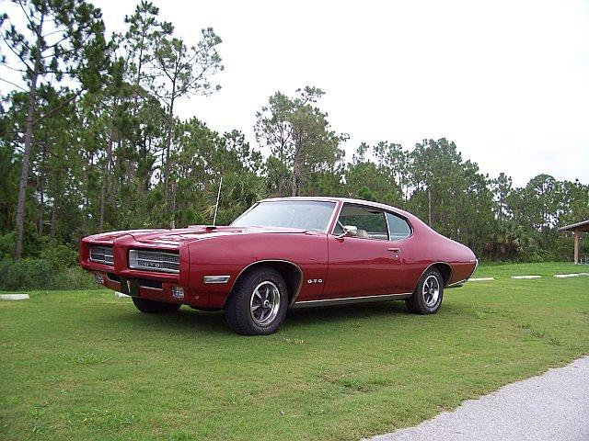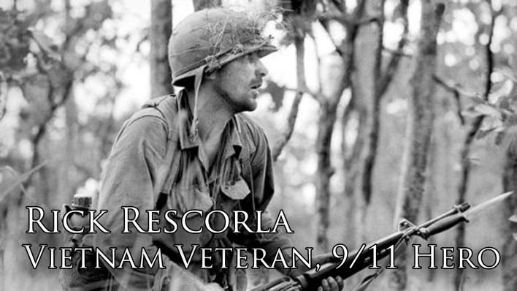

During the time that I was waiting for FINRA to reveal their examination findings, I decided that in July of 2006, which was coming up on the fifth-year anniversary of 9/11, there was something that I could do relative to that anniversary. So I decided to reach out to Rick Rescorla's widow, Susan. Rick was the director of security at Morgan Stanley and was credited, as you may know, with saving 2700 plus lives of Morgan Stanley employees because of his actions. And I thought on a fifth-year anniversary, maybe there was something that Susan would be thinking about that I might address. I did find her number, and she was nice enough to take my call, and I introduced myself.

And much to my surprise she said there's a problem. At this point she wanted to send me a video of Rick's statue dedication at Fort Benning, which was done in April of 2006. And then I want to tell you that there's been a disjoint relationship with Morgan Stanley, relative to the foundation. And we have a shortfall in being able to provide the granite base, which would hold the statue on the Memorial Walk of Honor at Fort Benning, which later was placed in 2009.

Susan sent down the video, and a recording of Rick's favorite songs. And I looked at it and the video was at the dedication of the statue attended by both of the other trustees Dan Hill and Fred McBee along with Susan, with the Fort Benning soldiers, and members of Rolling Thunder. You may want to see this ceremony. And, of course, the artist and General Moore who you might remember was portrayed in the movie We Were Soldiers, when Rick was the platoon leader for platoon B in that particular fight in la Drang Vietnam.

Anyway, I looked at all of this and so forth, and she mentioned the figure that they were short of funds on providing the granite base. Apparently a commitment had been made by Morgan Stanley and had not been fully honored. I decided, in view of the fact that I purchased an older vintage car in 2004, a bit of muscle in my engagement with Morgan Stanley, and we're now in 2006, that the end of the FINRA examination would end my participation. I opted to dedicate the car and send it to them so that they could sell it and have enough funds for the base of the statue. I wanted to show you the pictures of the car. The young man on the hood of the car was a little less than three in the picture. And he is now 19. A lot of time has drifted by.

There is more to this story, but it doesn’t need to be discussed in this context. I did mention to Susan that in the video there were no representatives of Morgan Stanley talking at the dedication. And she came back with the fact that none of them were invited for the April 2006 event due to the deterioration of the relationship. And then in 2009 before the placement of the statue at Fort Benning which I did attend, I did send her an email asking if this would be a time to let go of those feelings and offer a participation by Morgan Stanley with their appreciation for Rick's sacrifice. Rick was credited with saving approximately 2700 Morgan Stanley lives in the 9/11 attack and sacrificing himself in the process. Wouldn’t you have thought that those fortunate souls would have been well informed of Rick’s Ft. Benning

honor and been the first ones to offer financial support for the modest sum necessary to secure the base for the statue? I was shocked to find this out, but at the same time happy to lend my support and the relationship I forged with Susan, Rick’s children Trevor and Kim and the other foundation trustees Fred McBee and Dan Hill.

My email to her should reflect that my personal dispute with Morgan Stanley was totally separate from the Rescorla Foundation issues. I am including my email suggestion to her and her response. I want you to know that Susan did respond 4 minutes later. I think that you should know that I wanted to support the Rescorla's as the statue was being placed beautifully at the Ft. Benning Infantry Museum on the Memorial Walk of Honor. He deserves so much appreciation and none of those saved by Rick apparently were in attendance to honor his efforts. A sad part of his amazing legacy. I am very happy that I chose to attend the event and participated in the foundation’s financial needs.

Take a few minutes and watch the 2 videos I have placed on the domain site. You’ll be able to share some very special comments. As, honestly, I thought that my battle with Morgan Stanley and the regulators was coming to an end, a fitting gesture to Rick and the many lives he saved was to offer my symbol of my fight with Morgan Stanley to the Foundation. But, of course, along came the WSJ article in May of 2008, and I wasn’t about to walk away from the information which eventually and vividly showed the violations. Think of it this way: if you had information which could assist others, would you walk away or continue to face the opponents and obstacles ahead?

If you would like to learn more and see detailed documentation for this chapter, please visit our website at www.mswhistleblower.com. There, you will find extended information to help you get the best understanding through video, audio and supporting files.

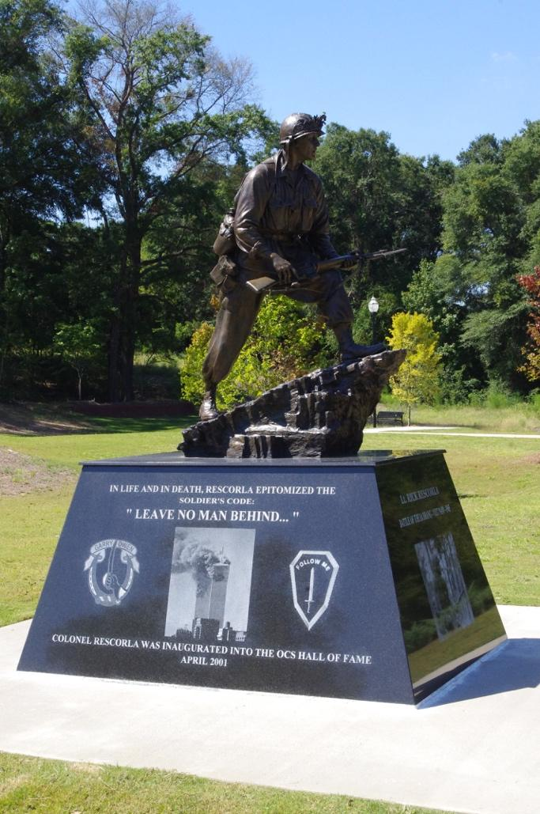

**The Adams Lineage**

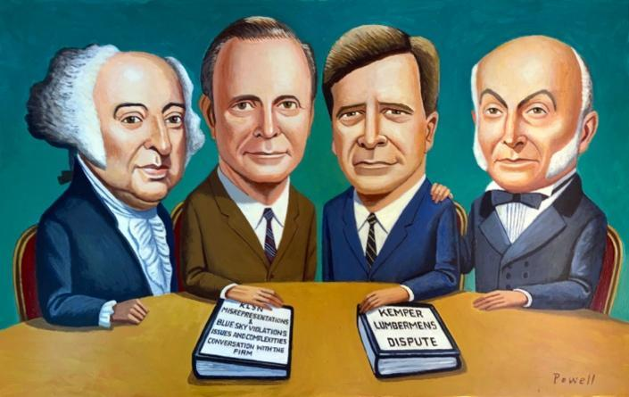

There is part of my lineage which is special and which I identify with very closely, being the family historian. I have a family tree, which was completed back in the early 1900s, which reaches back into the 1600s. And my seventh- generation grandfather ended up being John Adams, and consequently, my sixth- generation uncle is the man I more easily identify with, John Quincy Adams. As I have done throughout the last 18 years, I took time to visit Braintree Massachusetts, where both men are interred at the United First Parish Church. I took time to stand next to John and Abigail Adams and John Quincy and Louisa to share my thoughts about this in hopes that maybe the proximity to their spirit would again boost me to move everything in the right direction. So, I thought I would share with you an important clip from the movie Amistad which will give you a glimpse at John Quincy, and then I'll tell you why I think we're alike and how this plays into the final chapter of this ordeal. Please now sit back and enjoy the 7-minute clip of a man who meets a tough challenge and resolves the Amistad matter in 1841. I like men who stand strong when the powerless are at risk. Take time to view the video now.

I believe that is an honest and true depiction of my uncle. And I certainly have enjoyed seeing how he was portrayed in the movie. You know, he didn't choose to volunteer as counsel in the Amistad matter. He was solicited. I certainly didn't choose and solicit my way into an 18-year fray with Morgan Stanley and their regulators, it just kept going. When the situation dictated that there needed to be another opening, it appeared and, of course, I was the only one around to try to recognize it. In the clip, he got annoyed periodically. And certainly, so have I during these many years. His case was significant, and so is this. He suggests that it's who tells the best story wins. I have endeavored to do this. Such an important comparison is the value of invoking one’s ancestors for their inspiration and guidance when a situation seems dire.

Clearly, I have used that as Cinque did. I visited the United First Parish Church in Quincy, Mass. several times. When Morgan Stanley took me on, they took on the strength of my family. I am proud to have taken on this challenge and will always remember “who we are is who we were.”

I reached out to the outstanding illustrator, Charlie Powell, who was responsible for the illustration of me in the WSJ article of May 24, 2008. I asked for his permission to use the illustration and he willingly said yes. And then it occurred to me that if I am letting you understand how valuable my ancestral connections are, that he would paint a second illustration of four key members of The Committee, with whom I sought direction and support. Thank you, Charlie, for depicting the members accurately and warmly as I continued to lean forward against Morgan Stanley and their regulators.

Morgan Stanley needs to step forward as others have in their lives, like John Quincy and Rick have done to tackle difficult situations. Be brave and courageous and meet your responsibility. That's all I have to say.

If you would like to learn more and see detailed documentation for this chapter, please visit our website at www.mswhistleblower.com. There, you will find extended information to help you get the best understanding through video, audio and supporting files.

**Where's the driving force?**

I believe that I would like to conclude this story with a thought or two about the necessary responsibilities we all have to work together to identify a wrong and stand up strong to make it right. I have offered some difficult information for you to swallow in my effort to bring you on board in understanding the intentional decisions made by many to violate others.

Coincidentally, two actions took place in 1829 that are interesting to reflect on. The first was the final year of John Quincy Adams presidency and the second took place with a composition in four parts, each following without a pause. Why do I say without a pause? It’s because I can say without hesitation that for over 19 years, and the ramifications of that lengthy time, this matter has been a “constant companion” both day and night trying to get those who should assist to assist, and I can say that I have not paused either..

The second action occurred when Gioachino Rossini wrote an overture not knowing that it would evolve into an anthem expressing a feeling, for many of us, of optimism, right over wrong and a feeling of exhilaration. You will see that it takes perfection, coordination and zeal to get this absolutely right, allowing the listener to feel elated at the crescendo. I have tried to get this right as well.

So, I offer you a few moments to listen to and understand that the William Tell Overture is my way of letting you know that it was my turn to step up and help solve the mystery behind the deliberate wrongdoings of Kemper Lumbermens Surplus Notes. So, sit back, turn up the volume, put a smile on your face and stand with the crescendo!!!! This is for my special inspiration from both John Quincy and Rick Rescorla with thanks.

If you would like to learn more and see detailed documentation for this chapter, please visit our website at www.mswhistleblower.com. There, you will find extended information to help you get the best understanding through video, audio and supporting files.

**The Committee**

I wanted to acknowledge several of the many helpful members of The Committee who have listened, discussed and encouraged me, each in their valuable way, to stay with it until the point we have now reached. I wanted to identify each, of course with their permission.

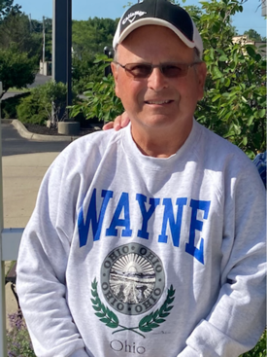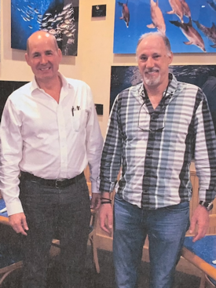

Wayne Dodds, Mike Blankenship, and Rich Mittnacht

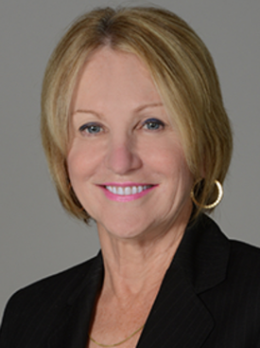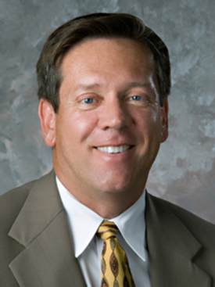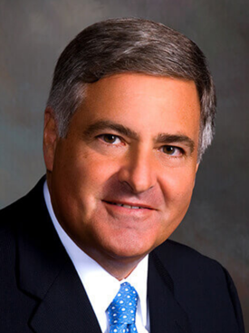

Rose M. Schindler as counsel, Glenn J. Webber esq. & Jack Scarola as counsel

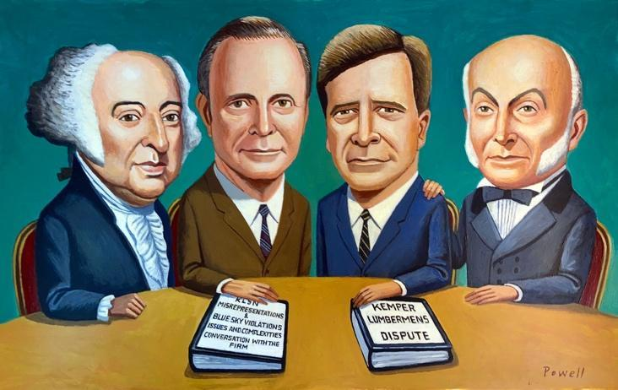

J. Adams, Del de Windt, Dana de Windt, J.Q. Adams

**6 Songs**

Motivation for staying the course can come from lots of sources. I thought I’d share with you several songs I've listened to while trudging forward was tough at times. I've included all six songs, some of them you probably have never heard before. Some are from my mid-teens. And each of them played a part in maintaining my balance in the face of some of the stress that I've gone through over the years trying to move forward. So, here's how I feel about the six. During my ordeal with Morgan Stanley and the regulators, the negative sets in frequently. And you ask yourself “why try”. which brings you to wonder if you should “forget it all”. Often, I needed during the lonely months and years ahead to have others stand down and “Please” don't say nothing at all. How many restless nights were fraught with “pulsating dreams” of power-driven men and women masterminding the steps to suppress the truth about these “bringers of darkness?” Then along came the special lyrics of “life uncommon”, reminding me many times that indeed, “we are tired, we are weary, but we aren’t worn out.” And finally, in a March 18, 2018 concert in the third row at the Sunrise Theatre in Fort Pierce, I saw a man who I've had a high regard and respect for a long time, John Kay and his band Steppenwolf. I heard him tell all of us to “hold on” , never give up, never give in, and this allowed me to relax for the last three years and “feed the fire”.

If you would like to learn more and see detailed documentation for this chapter, please visit our website at www.mswhistleblower.com. There, you will find extended information to help you get the best understanding through video, audio and supporting files.